Zebra Puzzles, also known as Einstein’s Riddles, are a type of logic puzzles where you have to use the clues to make logic deductions in order to solve a given problem.

The most famous Zebra Puzzle was created by Einstein and published in 1962.

Our zebra puzzle will be based on the following scenario:

*Three kids went to a superheroes fancy dress birthday party.  
The names of the three kids are Ethan, Ali and Anya.  
They dressed up as Spiderman, Captain America and Iron Man.  
The kids are 6, 8 and 10 years old.*

*We don’t know how each kid dressed up or how old each kid is but we have the following clues:*

* *Anya was dressed up as Spiderman.*
* *Ethan was not dressed up as Captain America.*
* *The youngest kid dressed up as Spiderman.*
* *The kid who is 8 years old dressed up as Captain America.*

You can solve this puzzle manually using the following grid:  
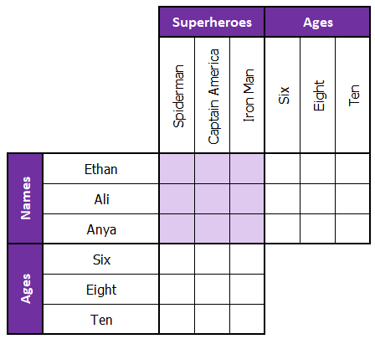

Try to solve

1. There are five houses.
2. The Englishman lives in the red house.
3. The Spaniard owns the dog.
4. Coffee is drunk in the green house.
5. The Ukrainian drinks tea.
6. The green house is immediately to the right of the ivory house.
7. The Old Gold smoker owns snails.
8. Kools are smoked in the yellow house.
9. Milk is drunk in the middle house.
10. The Norwegian lives in the first house.
11. The man who smokes Chesterfields lives in the house next to the man with the fox.
12. Kools are smoked in the house next to the house where the horse is kept.
13. The Lucky Strike smoker drinks orange juice.
14. The Japanese smokes Parliaments.
15. The Norwegian lives next to the blue house.

Now, who drinks water? Who owns the zebra?